Author: Oghenekevwe Jeffery Onodje
Title: Network Scan Report 1
Tool Used: Nmap and Command Terminal
Target: Localhost
Date: 26th March, 2026

Objective: to perform a basic network scan on a local system using Nmap in order to identify open ports and running services, and to understand potential security risks.
METHODOLOGY:
- A TCP scan was carried out using the command line: nmap -sS localhost
This is to discover open ports.
- A service version detection scan was also carried out using the command line: nmap -sV localhost
This shows what software is running on an open port and its version.
- A host discovery scan was then carried out using the command line: nmap -sn 192.168.1.0/24
This is simply to discover what devices are active on the network
EVIDENCE:
- Figure 1: Nmap TCP SYN Scan Result
The output shows multiple open ports on the localhost network.
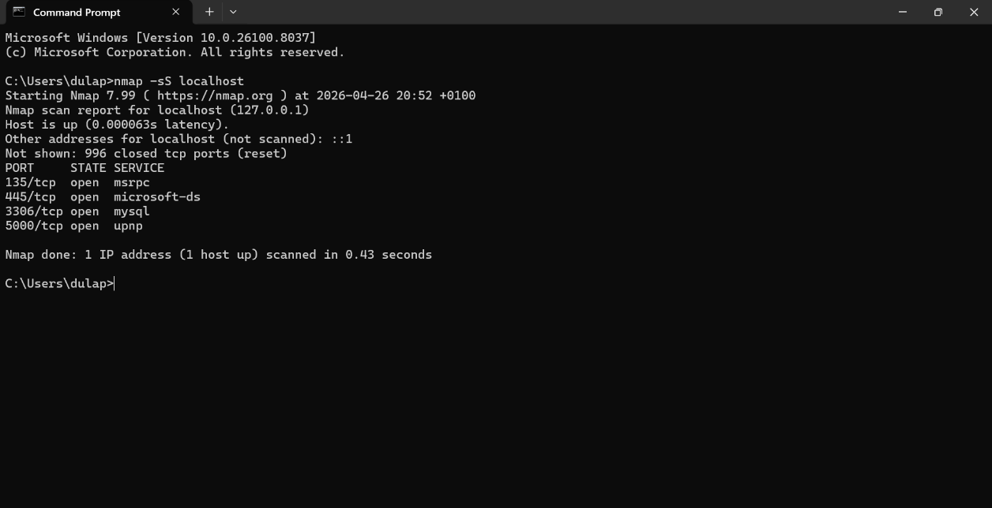

- Figure 2: Service Version Scan Result
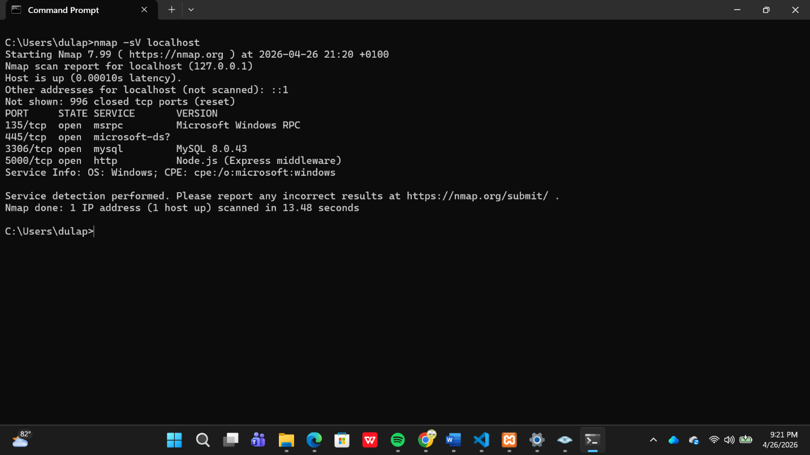

- Figure 3: Host Discovery Scan Result
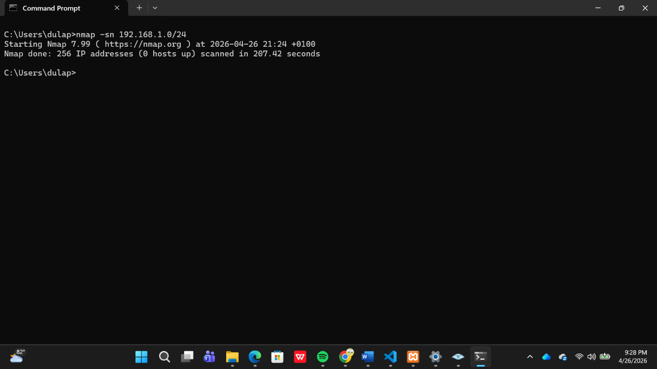

FINDINGS:
Port | State | Service | Description | Risk
135 | Open | msrpc | Microsoft Windows RPC | Medium - High
445 | Open | Microsoft-ds | SMB | High
3306 | Open | mysql | MySQL 8.0.43 | Medium
5000 | Open | http | Node.js(Express Middleware) | Medium - High
Further enumeration could be performed on detected services to identify vulnerabilities.

SECURITY ANALYSIS:
- The scan identified multiple open ports, including 115 (MSRPC), 445 (SMB), 3306 (MySQL), and 5000 (HTTP).
- Port 445 (SMB) presents a critical risk due to its history of exploitation in attacks such as the WannaCry ransomware. Immediate restriction is recommended using a firewall.
- Port 3306 (MySQL) exposes a database service which may be vulnerable to brute-force or unauthorized access if not properly secured. Remedy: Enforce strong authentication on MySQL.
- Port 5000 indicates a Node.js web application, which may introduce application-level vulnerabilities if not hardened. Remedy: Ensure that the NodeJS Application is not publicly exposed.
- Overall, the system presents a moderate to high attack surface and requires immediate hardening, particularly around SMB exposure and database access controls.

LIMITATIONS:
This scan was conducted on localhost, meaning results may differ in a real-world network environment. External exposure and firewall configurations were not assessed.

CONCLUSION:
The scan identified several open ports and active services that increase the system’s attack surface. High-risk services such as SMB, along with exposed database and web application ports, may be exploited if not properly secured. Implementing access controls, restricting unnecessary services, and applying security best practices are essential to reduce potential vulnerabilities.

FUTURE WORK:
- Perform vulnerability scanning using tools like Nessus
- Conduct deeper service enumeration
- Analyze web application security on port 5000

